Python Bytes Take Home Sheet 5
Some fun coding exercises for you to do! No stress! If you have any questions, feel free to mark them up and ask.

Activity 1: What will the following code do? Predict first, then run the code to test your predictions. You can use scratch paper! Note: the quotation marks get messed up if you copy paste into VSCode, so change those in VS after copying.

- 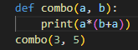
- 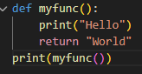
- 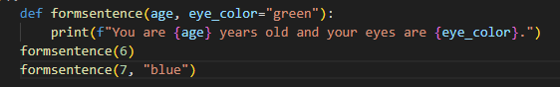
- 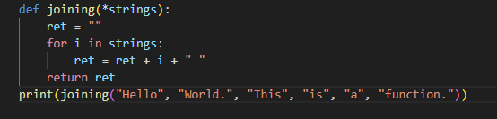
- 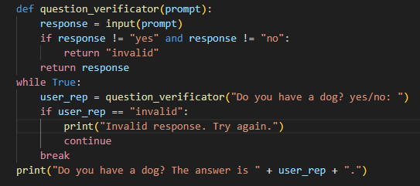

Activity 2: Predict what the following code will do, then run it! This one is not required. It is difficult, but if you think hard enough, the following code will start to make sense. Feel free to search this up!
This is called recursion.
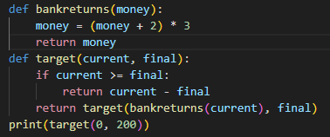

Another interesting application! This is called closure functions. What will this result in?
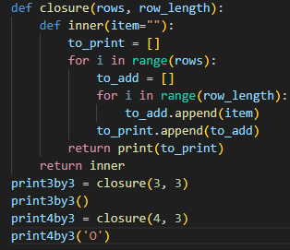

Activity 3: Let’s take our knowledge and have fun with it!
You’ve joined the Secret Order of the Code, a hidden organization that communicates through encrypted Python programs.
Last night, the Order’s central terminal was hacked and the security systems were shut down. However, the security systems still caught a strange set of clues–a set of numbers.
You found this note given by the hacker:
The sum is never what it seems.
The mirror hides the truth.
Only those who double back can restore balance.
And the numbers left by the security program:
numbers = [3, 7, 2, 8]
Your tasks are to:
- Define a function mirror_encryption(code) that:
  - Reverses code (which is a list)
  - Adds and subtracts alternatingly (so if code were [0, 2, 5, 3] it would be 0-2+5-3 = 0)
  - Returns the remainder of that divided by 11.
- Define a function find_number(start_multiple, number) that:
  - Finds the number that is between start_multiple multiple of 11 and start_multiple+1 multiple of 11 that has remainder number. (x % 11 = number, start_multiple*11 <= x < start_multiple*11+11)
- After defining these functions, use it to find the time the hacker started the hacking. You know that:
  - The numbers left by the security program were at the start of every hour after the intruder came in, and the security program stopped giving numbers at 8 AM.
  - The minute of the hour the intruders came in is equal to find_number(len(numbers), mirror_encryption(numbers))

